To: Sebastopol City Council Members + Post for Public
From: Councilmember Hinton, SCTCA Director

Notes from SCTCA Board of Directors Meeting on 9/14/2026, Start Time: 2:30pm

- Board Packet linked here;
- Full video recording is available here.
- Additional Public Comment items received during and following the Board meeting, attached here.
- Consent calendar was approved and links to all presentations are included below.

  - Programming – SCTCA Funding Program Cycle 2 Final Draft Programming Recommendations - APPROVED
Presentation: SCTCA Funding Program Cycle 2 Staff Recommendations
  - Climate – EV Charging Plan for Sonoma County:
Presentation: Equitable EV Charging Plan for Sonoma County
  - Climate – Climate Strategy Ad Hoc Report:
Presentation: Climate Strategy Ad Hoc
  - Climate – Current Status of Building Energy Reach Codes :
Presentation: Current Status of Building Energy Reach Codes
  - Projects – Resilient SR 37 Program Update and State Route 37/121 Long Term Improvements and Lakeville Highway Corridor Improvement Project Agreements - APPROVED
Presentation: Resilient SR 37 Program Update
6.4 Activities Reports – Informational
Presentation: SCTCA August Activities Reports
Our next Board Meeting will be October 19, 2026.


Page 2

Some Highlights from the slide deck at SCTCA Transit Ad Hoc Meeting on 9/23/2026,
Start Time: 9:00am
(3 slides below)

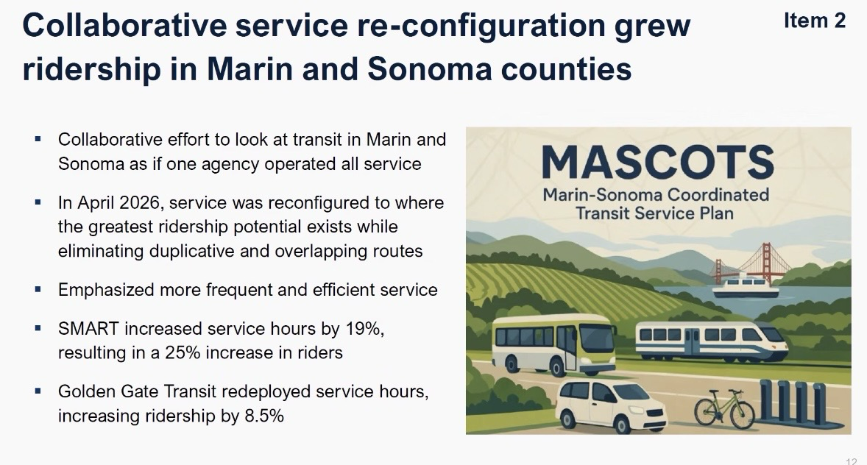

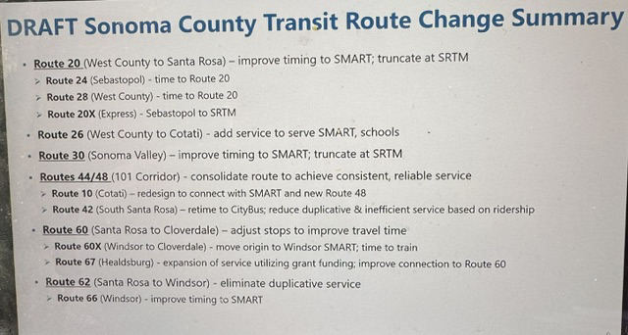

Page 3

