DRAFT

City of Sebastopol
Planning Department
7120 Bodega Avenue
Sebastopol, California 95472

, 2023

Call for Artists
Sebastopol South Entrance Public Art Project

The City of Sebastopol Public Arts Committee is seeking proposals from California-based artists for the design, fabrication, and installation of permanent, durable, and low-maintenance original public art suitable for placement
Funds for the budget for this project come from the City of Sebastopol’s Art In-Lieu Fee Fund that is set aside for public artworks.

SUBMISSION DEADLINE: (4 month minimum), 5:00 p.m. on Tuesday, .

Project Contact: planningtemp@cityofsebastopol.org

About Sebastopol

Sebastopol, located in Sonoma County, California was incorporated in 1902. Sebastopol is a ‘general law’ Council-Manager city with five Council members elected at large. Boards and Commissions include the Public Arts Committee.
Sebastopol has a unique and highly-valued small-town character. An incorporated City of 7,600 residents located in the San Francisco/North Bay region, Sebastopol is the hub of west Sonoma County, which is known as a creative center within the County.
While the incorporated area is small, Sebastopol serves a much larger unincorporated area stretching to the Pacific Ocean and the Russian River. Persons with a ‘Sebastopol’ mailing address number over 25,000. The City’s ‘market area’ comprises a population of approximately 40,000-50,000 people, who, to varying degrees, use Sebastopol as their ‘town’ for goods, services, and recreational and cultural activities. Thus, the town has far more economic activity, as well as recreational and cultural services than would be apparent based simply on the incorporated area’s population.
The City has an extraordinary location, being surrounded by farmland, vineyards, orchards, rural residential and wetlands, located minutes from the Sonoma Coast and the Russian River area, and just 60 miles north of San Francisco. Sebastopol is at the crossroads of two State Highways, Highways 116 and 12, and is eight miles from Sonoma County’s largest city, Santa Rosa.
Sebastopol has an active population, highly engaged in community affairs. It is anticipated that there will be a high level of community involvement with this public art project.
City web site: http://ci.sebastopol.ca.us/
Experience Sebastopol web site: https://experiencesebastopol.com/
Public Art Objectives
Public art helps make our City more livable and more visually stimulating. The experience of public art makes the public areas of buildings and their grounds more welcoming, it creates a deeper interaction with the places we visit, and in which we work and live. Public art illuminates the history of a community while it points to the City’s aspirations for the future. A city rich in art encourages cultural tourism which brings in visitor revenues. Sebastopol values public art and artistic expression.
The City has a five-member Public Arts Committee to review public art proposals and perform related functions.
Project Objectives
The City is open to a range of proposals. There is no set theme or medium. Durability of materials and construction is of great importance for this public art project. Generally, potential opportunities and considerations associated with the project may include:
- Site-specific design that reflects the community
- Foster a sense of beauty, multi-layered meaning, or have other compelling attributes
- Be appropriate for a public space
- Help create attractive public places
- Be durable, safe, and low-maintenance
- Enhance the pedestrian environment
- Foster cultural understanding
- Highlight local history, culture, or environment

No logos, specific historic figures, mascots, or any expressions of hate are to be used.

All finalists are expected to stay on budget and to complete work in an approved time frame.

This project occurs in the context of the City as a public agency, which requires a deliberative, open, and inclusive public process.

Site

The Joe Rodota Trail is one of the most heavily-utilized in Sonoma County, as is Hwy 116 northbound adjacent to the entry point of the trail, serving a large population of resident both of the Town and the surrounding area.
ADD HISTORY OF jrt HERE…WHO JR WAS, HISTORY FO RAIL TO TRAIL SYSTEM.
The project site is a triangle of land adjacent to the entry point of the Joe Rodota Trail on Hwy 116 just south of the USPS Annex at 275 Petaluma Ave, Sebastopol, CA 95472. Petaluma Avenue is a heavily-trafficked roadway in Sebastopol, and is the major north-south route through Sebastopol. (BENCH – check with Reg Parks – relocation and replacement).

The artwork can be installed in the center of the site and proposals should indicate foundation/mounting requirements for the piece. Utility services are not available on the site.

There is no height limit on the site. However, the site has natural features such as trees that will be retains, we suggest the artists consider these in their proposals.

See attached map, site plan photographs and dimensions.

Eligibility

This competition is open to artists/artist teams living in the State of California. For purposes of this request, ‘artist’ or ‘professional artist’ means a practitioner in the visual arts, generally recognized by critics and peers as a professional of serious intent and ability.

Artists who are immediate family or business partners of members of the Public Arts Committee, City Council, or City staff are not eligible.

Durability, Maintenance and Safety

The durability, maintenance requirements, and safety of this project will be essential elements in the selection process.

All applicants are expected to consider the issues of long-term conservation and maintenance of public art, along with time and budget. The project will be located outside and in the public realm and may therefore be exposed to weather and physical stresses, as well as potential vandalism. The project should be fabricated of highly durable, low-maintenance materials. The selected artist may be required to apply an anti-graffiti coat to the finished product.

The environmental effects of this project, during and after installation should be considered. The City will ensure conformity with city standards of maintenance and durability, as well as ADA and safety standards.

Selection Criteria

Proposals will be evaluated based on both the art concept, and the qualifications of the artist.

The art concept will be evaluated based on appropriateness to the site, aesthetic quality, durability of the art, maintenance requirements, and safety considerations.

Practicality of the fabrication process; reasonableness of the project budget; and schedule may also be factors in the selection.

Previous experience in public art is highly desirable, but not required. Experience with public process, and demonstrated success in conceiving, fabricating, and installing durable artworks is also desirable. Such experience will be a factor in selecting proposals.

In selecting finalists, the Committee will also consider professional qualifications, i.e. record of artistic achievement, successfully completed projects, as evidenced by resume and professional recognition, and artistic merit as evidenced by submitted images.

The selected artist must be able to meet the City’s contract requirements, and in the course of the project process, be available to meet with City staff, the Public Arts Committee, the City Council, and the Sebastopol community at specified times. An agreement with the selected artist will establish a minimum number of such meetings.

Selection Process

The Public Arts Committee will select finalists.

Once the Public Arts Committee selects up to three finalists, artists/artist teams will be asked to develop an artwork proposal for the site. A $1,000 honorarium will be provided to the finalists who are selected and choose to continue in the process.

Finalists will be required to develop and submit an artwork proposal for the project. The City will make the proposals available for public review and comment.

Following the public review period, each finalist will be required to appear in person at their own cost, and make a public presentation to the Public Arts Committee, at which meeting public comment will also be received. Finalists will also be required to make a presentation and answer questions at a community forum.

The Public Arts Committee will make a selection recommendation to the City Council, who will consider the Public Arts Committee recommendation as well as any public comment, and make a final selection decision.

One artist/artist team will be selected for the project and will enter into a contract for design, fabrication and installation of the artwork. Consultation with City staff and the Public Arts Committee may be needed in the course of project implementation. Final City approval is required prior to the work’s installation.

Budget

The all-inclusive artist budget to be provided by the City is $30,000. This budget includes design, fabrication and installation, and also covers any other project-related expenses—including but not limited to design, fabrication, installation, transportation and travel, presentation materials, taxes, and insurance. City insurance requirements may be reviewed at: http://ci.sebastopol.ca.us/SebastopolSite/media/Documents/engineering_permits/Insurance-Requirements-for-Encroachment-Permits.pdf?ext=.pdf

SUBMISSION DEADLINE:

Project Timeline (some times are estimated and subject to change)

Call Released:
Submissions Due:
Finalists Selected: Estimated 60 days after responses due
Proposal Presentation: Estimated 40 days after finalists selected
Public Arts Committee Recommendation: Estimated 20 days after presentation
City Council Award: Estimated 30 days after Public Arts Committee recommendation
Installation: TBA

Submission Requirements

Your submission should include seven (7) hardcopy copies of the following, provided in the order listed:

- A Letter of Interest. In not more than one typed page, describe your interest in and qualifications for this project, and generally, the process you would utilize for the project, if selected.
- Art description/depiction. Using a text description please describe your concept for this project (250 word maximum), with or without a sketch or more specific visual image.
- Budget. Address each of the following elements in the following order (if not applicable, so indicate):
- Artist Fees
  - Design fees (may include research time and/or time spent with local groups getting pertinent information about our community.)
  - Structural Engineering
- Materials, Equipment, and Production costs
- Studio Fees
  - Rental if unique space needed for this project
  - Utilities (gas, water, electricity), if not included in rental
- Transportation of finished artwork to site in Sebastopol
- Installation costs, including any equipment rental
- Lighting costs
- Insurance
- Taxes
- Documentation

- A Professional Resume. List last name first. In not more than two typed pages per artist, provide an outline of your professional experience as an artist. If submitting qualifications as a team, please provide a simple resume for each member of the team with a maximum of two pages per team member. The resume should include descriptions of successfully completed similar projects, and client contact information.

- Images of Past Work. Submit up to ten (10) images of past work. Each image should be clearly labeled and include artist’s name, title of work, materials, dimensions, year, the commissioning entity, and project budget (if applicable). Do not submit more than two images of the same artwork. Images should be original works by the proposing artist(s).

- The artist’s name should appear on all materials submitted.

- One (1) digital copy of your complete submittal.

Please note:

- Respondents to this RFQ do so at their sole expense.
- All submittals will become property of the City. Do not submit materials you would want returned.
- Incomplete or unresponsive submittals may be rejected.
- Prospective consultants shall not contact Public Arts Committee or City Council members about this RFP without specific authorization from City staff. Doing so may be grounds for disqualification.
- The City reserves the right to reject any and all proposals and to cancel or alter the selection process at its sole discretion.

Questions

The Planning Department is managing this project. Any questions about the RFQ may be directed via email to:
planningtemp@cityofsebastopol.org

Submittals

Submittals shall be delivered to:

Planning Department, City Hall
7120 Bodega Avenue
Sebastopol, CA 95472
planningtemp@cityofsebastopol.org

Attachments:
Map
Site plan
Site photographs

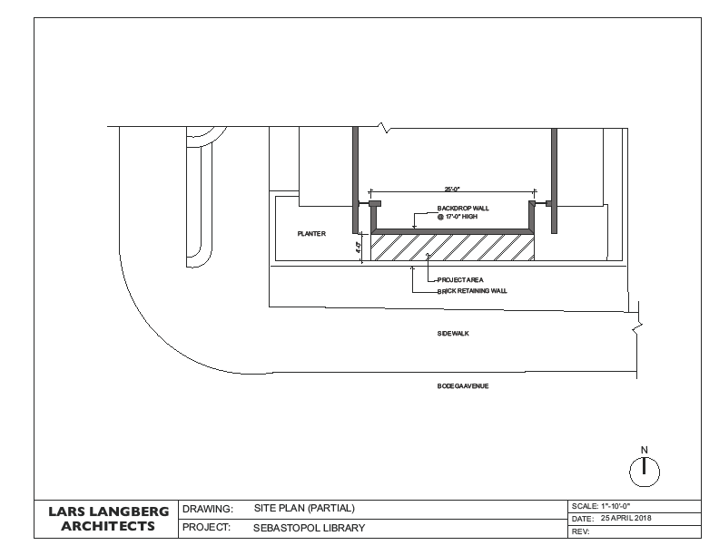

Call for Artists
Sebastopol Library Public Art Project
Site Photographs

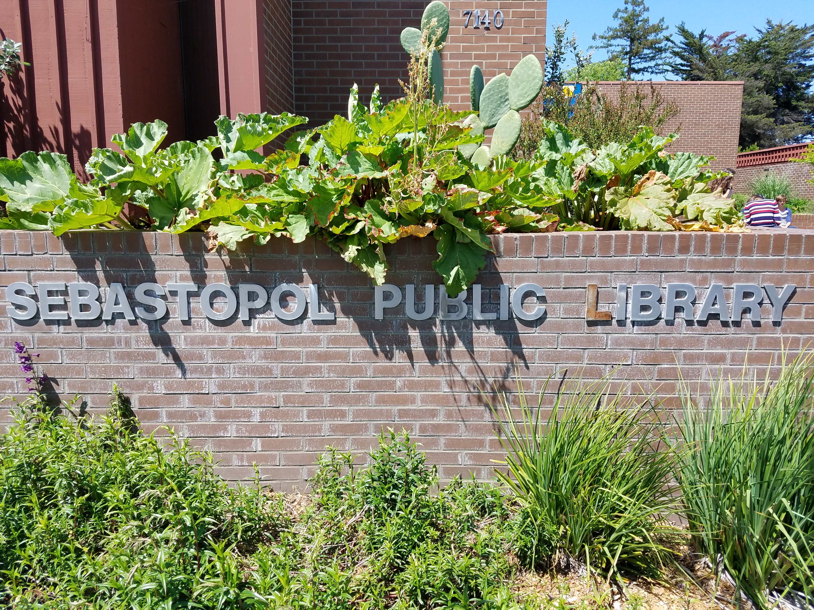
Bodega Avenue frontage

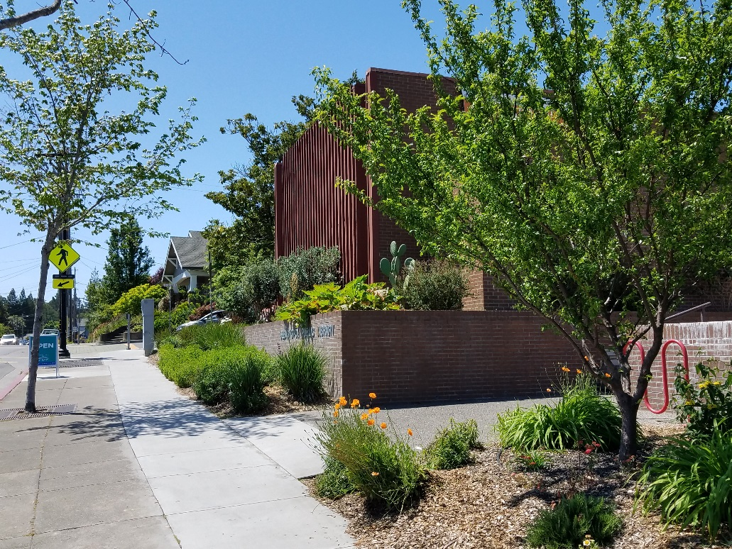
Looking west along Bodega Avenue

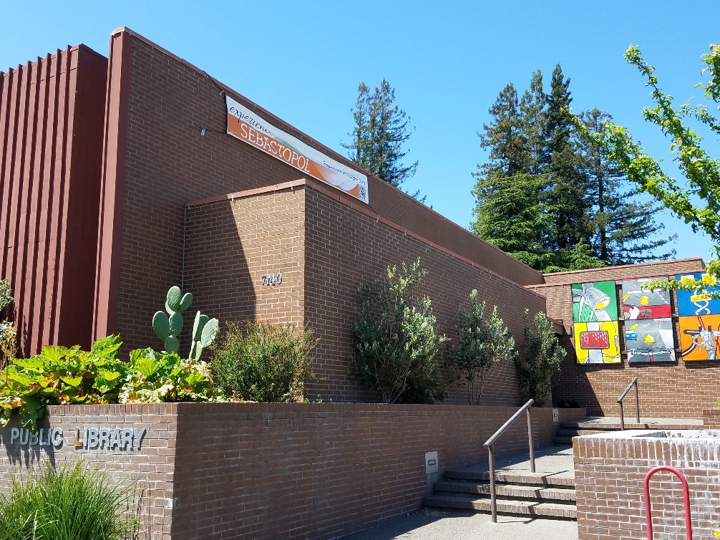
Easterly Library entry area

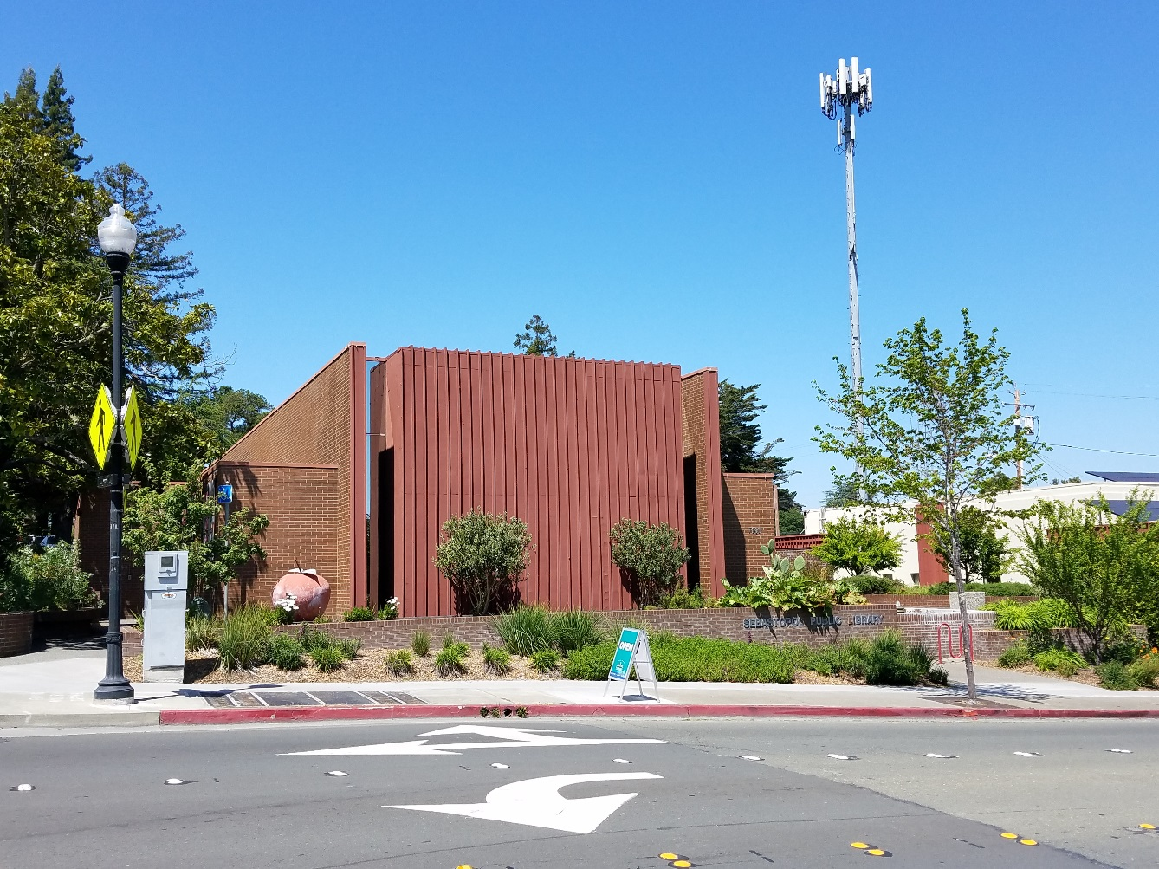
South-facing Library Forum Room wall, project site

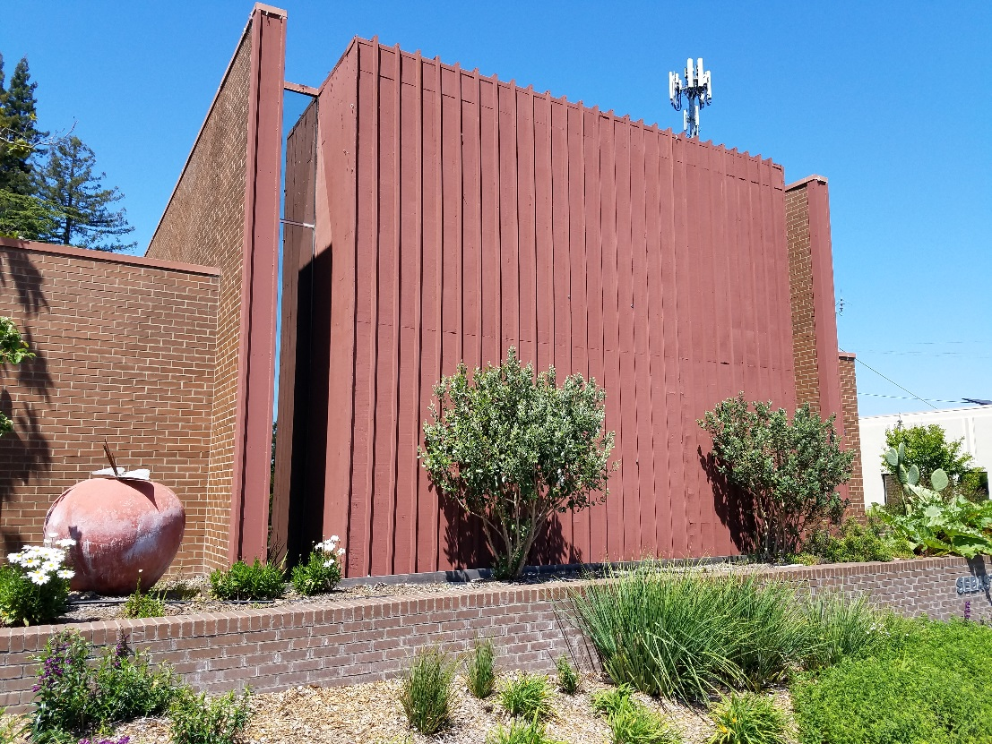
Project site wall; note retaining wall, landscaping

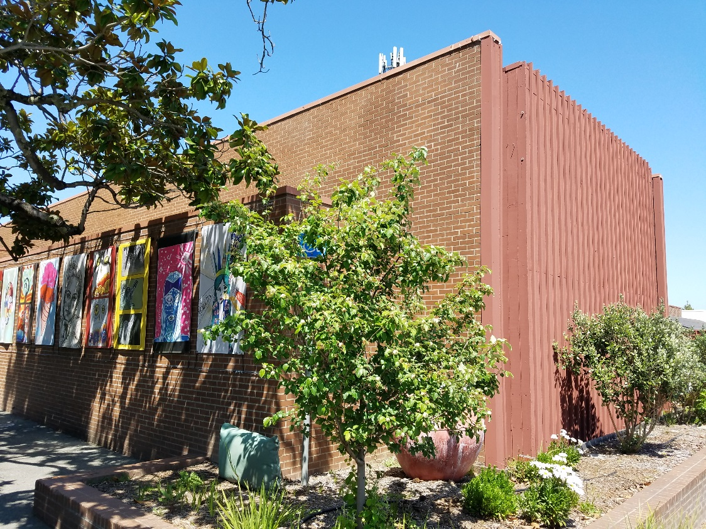
West-facing wall of Forum Room, corner of Bodega Avenue/High Street

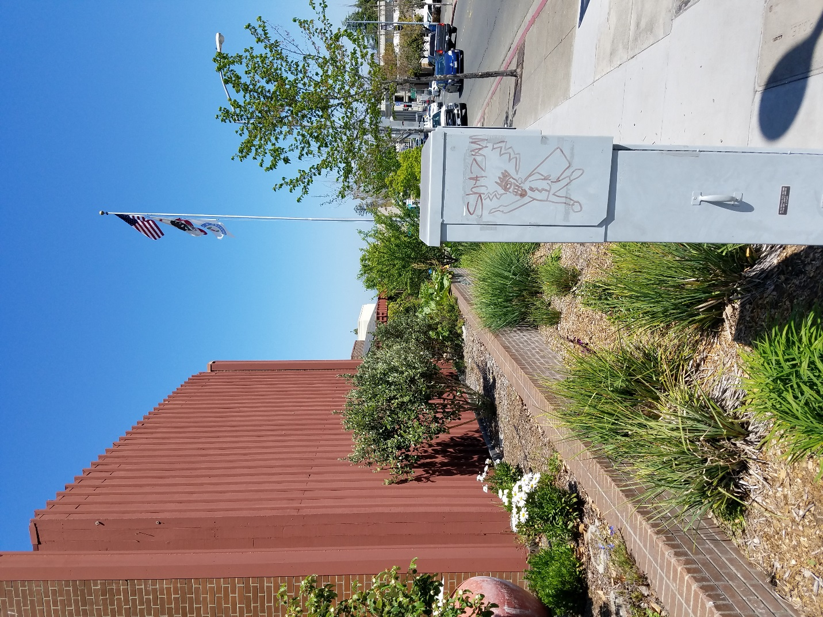
Looking east along Bodega Avenue frontage, utility box in foreground

